MINUTES OF A COMMITTEE OF THE WHOLE MEETING
OSWEGO VILLAGE PRESIDENT AND BOARD OF TRUSTEES
OSWEGO VILLAGE HALL
100 PARKERS MILL, OSWEGO, ILLINOIS
August 17, 2021

CALL TO ORDER
President Troy Parlier called the meeting to order at 6:05 p.m.

ROLL CALL
Board Members Physically Present: President Troy Parlier; Trustees Tom Guist, Kit Kuhrt, James Marter II, Terry Olson, Jennifer Jones Sinnott, and Brian Thomas.

Staff Physically Present: Dan Di Santo, Village Administrator; Christina Burns, Asst. Village Administrator; Tina Touchette, Village Clerk; Jeff Burgner, Police Chief; Jennifer Hughes, Public Works Director; Rod Zenner, Community Development Director; Mark Horton, Finance Director; Scott McMaster, ED Director; Joe Renzetti, IG/GIS Director; Kevin Norwood, Deputy Chief; Jenette Sturges, Community Engagement Coordinator, Marketing; Susan Quasney, Engineer; Karl Ottosen, Village Attorney; and Douglas Dorando, Village Attorney.

PUBLIC FORUM
Public Forum was opened at 6:05 p.m. There was no one who requested to speak. The public forum was closed at 6:05 p.m.

OLD BUSINESS
There was no old business.

NEW BUSINESS
G.1 Downtown Parking Discussion

Director Zenner and Engineer Quasney addressed the Board regarding parking in the downtown. Staff conducts occasional parking counts to determine the demand and usage of the downtown parking supply. On May 21, 2021, staff conducted a parking count to coincide with the recent opening of the Village’s parking deck. May 21st was chosen because it was a Friday, non-event weekend, with good weather which staff believes would provide a typical or a slightly higher than typical parking demand number. Counts were conducted every hour from 9:00 am to 7:00 pm.

Friday May 21, 2021
Time | Total # of Spaces | Spaces Used | Spaces Available | Percent Used
9:00 am | 1291 | 288 | 1003 | 22%
10:00 am | 1291 | 353 | 938 | 27%
11:00 am | 1291 | 341 | 950 | 26%
12:00 pm | 1291 | 338 | 953 | 26%
1:00 pm | 1291 | 339 | 952 | 26%
2:00 pm | 1291 | 347 | 944 | 27%
3:00 pm | 1291 | 297 | 994 | 23%
4:00 pm | 1291 | 335 | 956 | 26%
5:00 pm | 1291 | 356 | 935 | 28%
6:00 pm | 1291 | 377 | 914 | 29%
7:00 pm | 1291 | 357 | 933 | 28%

- The average percentage of parking spaces occupied was 26.1%
- At the peak, 29% of the parking was occupied at 6:00 pm
- The minimum parking percentage was at 9:00 am at 22%
- The average occupied rate in 2019 was 29.4%

The Downtown was split into 11 blocks for analysis. Overall, there are 1,291 parking spaces within the 11-block study including on street spaces, surface parking lots, and the new parking garage.

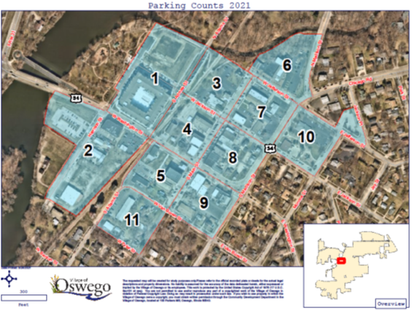

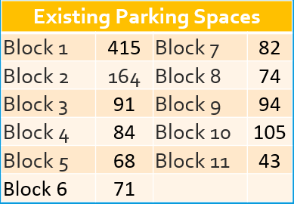

- Block 9 (at Main and Washington) had the highest percentage used at 70% at 6:00 pm, while neighboring blocks had a lower percentage used:
- Block 5 at 54% with its highest occupancy rate at 59% at 5:00 pm
- Block 8 at 46%
- Block 4 at 42%
- Block 4 is the most occupied at 48%
- Block 6 is the least occupied with an average of 13%
- The parking garage has occupancy rates between 9%-16%
- The average percentage occupied in 2021 was 26.1%
- In 2019 the occupied rate was 29.4%

Distance to Parking
As the Downtown continues to grow, patrons may find it necessary to park one to two blocks away from their intended destination. As a comparison, the distance from the middle of the Meijer parking lot to the middle of the Meijer store is 492 feet. The following shows a buffer of 492 feet from each of the access doors of the new parking garage and shows that the majority of the downtown is within this identified buffer area:

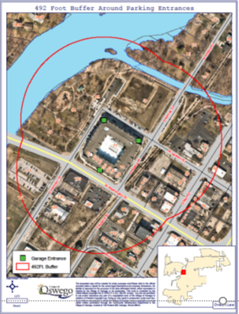

The distance between parking and destination is not unlike the conditions found in the Village’s Route 34 commercial corridor. One challenge to having customers park in the garage is the need to cross Washington Street at Harrison or Main. This challenge will be addressed with the installation of traffic signals, with pedestrian controls, at these intersections next year.

Potential for Additional Parking
Staff has identified several locations near the intersection of Main and Van Buren Streets that could accommodate additional public parking on the south side of Washington Street. Currently, there are five existing diagonal spaces near that corner, as well as parallel street parking to accommodate five more cars along Van Buren. There are a considerable number of spaces in the area that are physically located within the right-of-way (ROW) but have historically been used only for private businesses. The owners of 57 Van Buren, 126 Main and 76 Van Buren are open to discussing modifications for public use in select locations. Staff has also reached out to the owner of 73 Van Buren to discuss the possible addition of public parking.

It is recommended that these modifications be combined with watermain work along Van Buren, currently under design and planned for next spring. All identified modifications will add 18 spaces to the existing configuration, for a total of 28. The estimate for all modifications is just under $200,000.

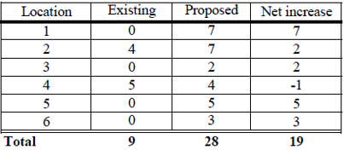

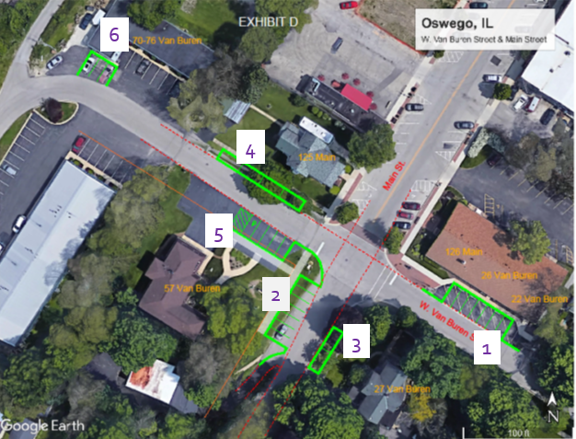

#1- 126 Main St (Schoppe Design)- Changing the existing striping at 126 Main from diagonal to perpendicular which adds two spaces at that location.

#2- 57 Van Buren- remove turf; build curb and gutter and add pavement width; build new sidewalk. Removing turf and pushing them west is beneficial in two ways. It adds enough street width to allow for parallel spaces on the east side of Main and it avoids encroachment into the driveway to the south, allowing for two additional spaces.

#3- 27 Van Buren- remove trees and turf; build curb and gutter and add pavement width. Due to the narrow width of Main St. south of the property, adding more spaces would require re-aligning the existing sidewalk which is not recommended at this time.

#4- 125 Main St. (north side of Van Buren)- remove trees and sidewalk; reconfigure with curbs and retaining wall; build new sidewalk. Limiting to four (4) parallel spaces avoids a ComEd pole and guy wire at the northwest corner of Main and Van Buren. To maintain the existing street width, parking would have to be moved further away from the roadway to facilitate new parking spaces on the south side of the street, in front of 57 Van Buren. The width of the street would not allow for a sidewalk on the south side without obtaining an easement from the property owner of 57 Van Buren. The cost is not currently included in the estimate and would add approximately $5000 to the project.

#5- Private parking at 57 Van Buren (Oswego Chiropractic)- remove and replace asphalt and stripe; install new sidewalk.

#6- 70-76 Van Buren- rebuild pavement and stripe. Only three of the spaces in front are located within the ROW. The remainder are on public property and would remain private parking. Underneath the three spaces is an old grain scale. The cost of removing and filling this space would have to be included in the modifications. It is hard to identify a cost for this work, but a substantial contingency has been included in the estimate to cover this.

One other possible location for additional parking spaces is the empty property at 63 W Washington. It was suggested that six or seven perpendicular temporary parking spaces could be created along the width of the alley until the property is sold for development. Plastic cellular pavers are relatively cheap and can create a usable driving surface that is in compliance with Village codes. The estimate for installed pavers is between $12,000 and $15,000.

Board and staff discussion focused on staff met with the property owner of 57 Van Buren to see if they would consider public parking; how many of 1,291 spaces are Village owned; overall demand; did not breakdown public versus private; ADA needs in the downtown; when addressing one need it causes another; more restaurants in the downtown may cause additional infrastructure needs; develop a Main St. master plan; how many private versus public spaces in #1, 5 and 6; not sure if diagonal striping is the safest way on Van Buren; advantage for perpendicular parking is that the spaces can be accessed from either direction; need more detailed drawings for #1-6; encroachment on the driveway; issues with weather and having to walk from the parking garage up the hill; whether to move to perpendicular in all of downtown; issue is the width of the streets; Main St. is not wide enough; obtain data on parallel versus perpendicular and number of accidents; can re-stripe if there are issues in some areas; conducting another parking count; usually do a parking count when a new business opens in the downtown, such as Dairy Barn; how much has COVID affected the counts; block by block counts; doing another count in the Fall when the weather is nice; retail spaces in the Reserves to open next summer; not enough public parking; work on Van Buren is under design and included in the construction scheduled for next Spring; need an easement agreement from Schoppe before doing any work; could re-stripe in the Fall; #2 will need to be part of the reconstruction; #4 will require a retaining wall; staff will talk to the owner of Oswego Chiropractic about the private parking spaces.

Owner of Oswego Chiropractic, Shane Wade, addressed the Board regarding his hesitation of losing spaces for his customers; should be limitations on timing; potentially widening; need stop sign at Main St. and Van Buren. Administrator Di Santo to schedule a time to meet with him on-site. There was no further discussion.

G.2 Non-Highway Vehicle Enforcement Overview

Chief Burgner addressed the Board regarding non-highway vehicles. The Oswego Police Department (OPD) has seen an increase in the number of ATV/Minibike (non-highway vehicle) complaints throughout the Village in 2021. Over the years, OPD received complaints and addressed the concerns through education and enforcement. OPD uses sections of the Illinois Vehicle Code to address complaints or observations of violations on the roadways.

Number of complaints of ATV/Minibikes being operated illegally in the Village:
- 2020= 127
- 2019= 33
- 2018=28
- 2017= 54

As of August 10, 2021, they have received 158 complaints for similar violations. From January 1, 2020, through July 31, 2020, they handled 45 ATV/minibike complaints and during the same time period in 2021, they handled 152 ATV/minibike complaints. The recent complaints have indicated the operators of the ATV and minibikes have become more brazen. The complaints include riding on roadways, wheelies, speeding, riding on private property, disobeying traffic signals and signs. On numerous occasions the OPD has witnessed some of these acts and the offender, on occasion, has refused to stop which is also an Illinois Vehicle Code violation. Staff has researched different methods of enforcement that can be used as a tool to assist the Department in addressing this issue.

Tools

- Illinois Vehicle Code- under Illinois Vehicle Code a “non-highway vehicle” is generally not allowed to operate on any street, highway, or roadway in the State unless local ordinance allows for said operation. The Village of Oswego does not have an ordinance that allows for operation of these types of vehicles to operate on the roadways. A “non-highway vehicle” is defined as an ATV, golf cart, off-highway motorcycle, and recreational off-highway vehicle. The Department uses sections of the Illinois Vehicle Code to issue citations regarding the use of non-highway vehicles on the roadway.

- Village of Oswego Code- Section 9-13-1 allows for the seizure and impounding of a motor vehicle that has been used in certain offenses. The most likely offenses that the OPD would use for ATV/minibike illegally driven on the roadway would be:

- No Valid Driver’s License
- Driving While License Suspended/Revoked
- Fleeing and Eluding
- DUI
- Reckless Driving
- Street Racing
- Speeding (more than 35 miles per hour over the posted limit).

The offenses of “Operating non-highway vehicle on streets, roadways, and highways (625 ILCS 5/11-1426.1 (b)” and “Operating non-highway vehicle on streets, roadways, and highways without a valid driver’s license (625 ILCS 5/11-1426.1(b-5))” are not currently listed as offenses subject to this Code under Section 9-13-1. Adding these two offenses to Section 9-13-1 as well as Section 9-13-7 (fee schedule for the seizure and impoundment of the vehicle) would assist in their ability to address the issue of non-highway vehicles operating on the roadways.

- Seizure and Forfeiture of Property- the OPD uses Article 36 of the Illinois Criminal Code (720 ILCS) to seek seizure and civil forfeiture of property for non-drug related offenses. There are numerous offenses that are listed within Article 36 that allow for vehicles to be subject to forfeiture if the vehicle is used in the commission of the offense. One offense of note, Aggravated Fleeing or Attempting to Elude a Police Officer (625 ILCS 5/11-204.1) is an offense listed with Article 36 that would make a vehicle eligible for forfeiture if used in the commission of the offense. Aggravated Fleeing and Eluding a Police Officer is also a Class 4 felony offense and the offender’s driver’s license is subject to being revoked if convicted. The OPD would also permanently take possession of the vehicle.

- Awareness/Community Assistance- the OPD is currently using social media and traditional media sources to engage the community in an effort to educate residents as well as solicit help in identifying the offenders. The OPD realizes that they will not always be able to stop and identify the offender in the act and follow up work will need to be conducted after the fact. This must be a collaborative effort between the OPD and the community in addressing this issue. They will continue to post images of suspects and vehicles to social media that have been obtained from officers, community members and other surveillance means and encourage the community to let them know addresses in the community that have non-highway vehicle operating illegally. This information can be shared in an anonymous manner.

Board and staff discussion focused on $500.00 administrative tow fee; offenses will be handled on a State and/or County level with charges that could run concurrently; relying on the community for help; follow-up investigations allow charges at a later time; with social media help, have been able to identify individuals and put them on notice; vehicles are not safe on the roadways; not designed to be on the roadways; recent accident with a youth who has significant injuries; who is at fault in these types of accidents; in the recent incident, it was the motorbike driver who received all the tickets; challenging because the vehicles can go where the squad cars can’t; hoping to increase the success rate with follow-up work and investigations; not specific to this area, it is happening across the country; of the 158 unique and independent complaints, it is unknown how many are licensed drivers; how far do you let this go before someone dies; need to adopt the ordinance and move forward. There was no further discussion.

CLOSED SESSION
A motion was made by Trustee Jones Sinnott and seconded by Trustee Olson to enter into Closed Session for
the purposes of discussing the following:

- Collective Bargaining, Collective Negotiating Matters, Deliberations Concerning Salary Schedules [5 ILCS 120/2(c)(2)]

Aye: Tom Guist Kit Kuhrt
James Marter II Terry Olson
Jennifer Jones Sinnott Brian Thomas
Nay: None
The motion was declared carried by a roll call vote with six (6) aye votes and zero (0) nay votes.

The Board adjourned to Closed Session at 6:53 p.m.
The Board returned to open session at 7:21 p.m. A roll call vote was taken. All remaining members still present.

ADJOURNMENT
The meeting adjourned at 7:21 p.m.

Tina Touchette
Village Clerk

